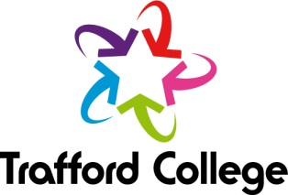
Around the World in 5 Weeks!

Poland, Iran, China, Holland and the UK are all part of Trafford College’s Community Learning International Cooking course. With learners from around the globe, the course was a true fusion of world foods and offered the opportunity to cook-up homemade, mouth-watering dishes from around the world including Sofritto, Chinese Stir Fry, Naan bread, Bombay Potatoes and Curry Pastes.
Funded by LARCO (The Locality Approach for Reducing Childhood Obesity) the course ran at Lime Tree Primary School in March 2015 in partnership with Trafford College and SureStart. Running over 5 weeks with a different global cooking theme each week, the grand finale took the form of a World Food Celebration in the final week. Children from the school joined in the session to sample home cooking at its finest and taste food from around the world. Dishes cooked up were Tzatsiki, Hummus, Tortilla Chips, Chinese Spring Rolls, Kookoo Sabzi, Kookoo Sibzamini and Dutch Poffertjes.
Laura Maggs, a Midday Assistant at Lime Tree Primary School, commented, “The course took me out of my comfort zone and I feel more confident about cooking new things. Usually, I stick to what I know and end up cooking the same meals week in week out, but this course has broadened my knowledge of world food and the different dishes that I can cook.
It has been really nice to meet other parents at the school, there was a lovely atmosphere in the room and we all enjoyed learning from each other.
The tutors were brilliant, they were really friendly and listened to all of the learners instead of saying ‘this is what you need to do’, and they worked with us which was enjoyable.
I would definitely recommend a Community Learning course to anybody as they are fun, help you learn new skills and get you out the house.”
The International Cooking course followed a Level 2 Food Safety qualification and the group are progressing onto a further cooking course, Summer Snacks & Salads. Having learnt how to prepare delicious home-made food from around the world, the learners can now dish up a recipe for success at home for their families.
For more information about Community Learning cooking courses, please call the Community Learning team at Trafford College on 0161 886 7445/7443.

