Welcome to



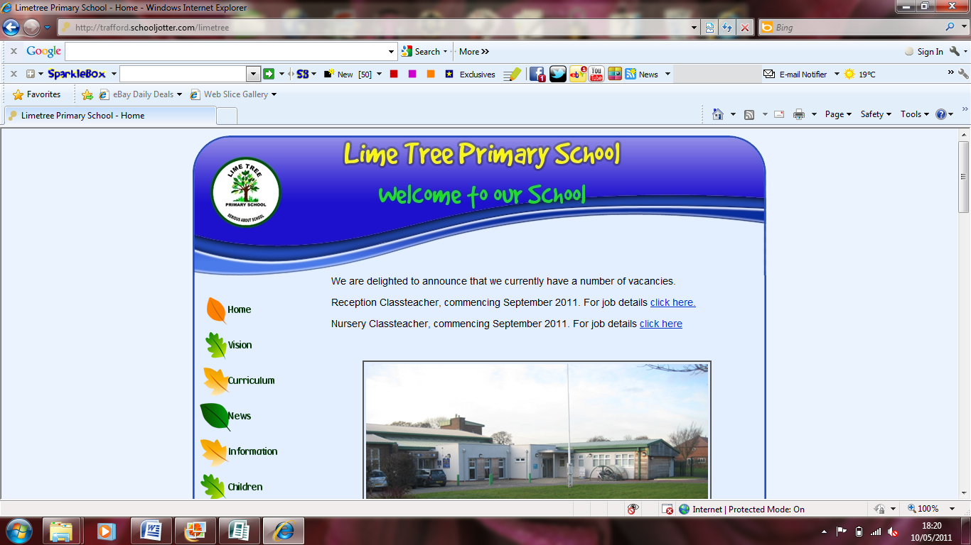

Tree Tots

Information and Welcome Pack

Budworth Road

Sale Moor

M33 2RP

(0161) 905 0790

<http://www.limetree.trafford.sch.uk/>

Email - [treetots@limetree.trafford.sch.uk](mailto:treetots@limetree.trafford.sch.uk)

**Welcome to Lime Tree Primary Academy**

Lime Tree is a school that encourages and celebrates a love of learning where each pupil is known and cared about as an individual. We have created not only a school but a community of pupils, parents and teachers brought together by their shared dedication to doing whatever it takes to achieve success.

Our teachers are high performing professionals who go above and beyond expectations to make a difference to pupils’ lives.

Lime Tree has the highest academic aspirations and, at the same time, maintains a caring, family orientated culture. To realise our hopes and dreams for the school we ask more of ourselves and more of our parents and pupils.

Our curriculum is rich, innovative and varied. It celebrates all skills and subjects giving our pupils life changing opportunities

Our school is a calm, orderly environment that embraces all learners. We have the highest expectations for each and every member of our school community.

We are dedicated to ensuring all our pupils succeed, challenging and developing their ability to think independently, enabling them to transfer their learning to all aspects of their life; preparing them for the future.

Lime Tree is a nationally designated Teaching School in recognition of our partnerships and collaborations built from our work supporting schools across the whole of the Greater Manchester region.

Our school hosts a cohort of Schools Direct students each year and regularly welcomes educational visitors nationally and internationally.

Mr. Simon Beswick Mrs Clare Larkin

Executive Principal Head of School

**Welcome to Tree Tots**

We are delighted to welcome you and your child to Lime Tree Primary Academy. Tree Tots pre-school is an academy run provision for 2 to 4 year olds based at Lime Tree. The aim of our Early Years provision is to prepare children for school readiness. The ‘Tree Tots’ provision is part of the school Early Years Foundation Stage and the staff work closely with the established Foundation Stage team, including 4 qualified Early Years teachers, sharing their skill sets. This provision is available during term time, operating between the hours of 8.00am and 3.30pm.

We believe that children deserve high-quality care and learning experiences to enable them to learn effectively. We provide a purposeful, fun, safe and secure environment where the children enjoy activities based around their interests and developmental need. The provision offers teacher-supported learning through play, based around the Early Years Learning Framework. We believe that children make the greatest progress when they are fully engaged, have high self-esteem and feel confident within their surroundings.

**How You Can Help Your Child to Learn**

* I can settle happily without my parent or carer;
* I can tell friends and grown-ups what I need;
* I can take turns and share when I am playing;
* I can go to the toilet on my own and wash my hands;
* I can put on my own coat and shoes and feed myself;
* I can tell a grown up if I am happy, sad or cross;
* I know that what I do and say can make others happy or unhappy;
* I am curious and want to learn and play;
* I can stop what I am doing, listen and follow simple instructions;
* I enjoy sharing books with grown-ups;
* Learning Journey Contributions – in the Tree Tots we collate a picture of your child’s journey throughout their time. Collecting observations whilst they are learning and taking photographs. In this learning journey we have a section for anything your child has done at home which they would like to put in their learning journey. We actively encourage you to contribute to this via notes, pictures and emails.

**Tree Tots Times of Day**

|  |  |
| --- | --- |
| **Morning Session** | **Afternoon Session** |
| 8.30am until 11.30am | 12.30pm until 3.30pm |

**Breakfast for Tree Tots**

Tree Tots offer a breakfast club which is available from 8.00-8.30am and is chargeable (see prices below). It is based within the Tree Tots room. This needs to be booked in advance with Jenny (Tree Tots manager).

**Prices**

|  |  |
| --- | --- |
| **Breakfast club** | **Full Day** |
| 8.00am until 8.30am  £5.00 | 8.30am until 3.30pm  £33.00  (Packed lunch needs to be provided) |
| **Morning Session** | **Afternoon Session** |
| 8.30am until 11.30am  £15.00 | 12.30pm until 3.30pm  £15.00 |

**School Uniform**

A school uniform is optional at Tree Tots. Throughout their Tree Tots session, your child will be taking part in hands-on experiences that can be physical, creative and messy for example painting, shaving foam, and gloop. Please ensure that if you do not purchase a uniform thattheir clothing is appropriate. Although a tabard will be worn throughout messy activities**,** clothes can still be affected**,** so please do notbring your child in with their best clothes on. The school uniform is as follows:

|  |  |
| --- | --- |
| **Boys** | **Girls** |
| * navy blue Lime Tree round neck sweater * white polo shirt * navy blue jog pants with elasticated ankles * plain black Velcro trainers or school shoes * black socks   **Summer Uniform:**   * navy blue Lime Tree round neck sweater * white polo shirt * navy blue shorts * plain black Velcro trainers or school shoes * black socks | * navy blue Lime Tree round neck sweater * white polo shirt * navy blue jog pants with elasticated ankles * plain black Velcro trainers or school shoes * black or white socks   **Summer Uniform:**   * navy blue Lime Tree round neck sweater * white polo shirt with navy blue shorts   or   * dark blue checked summer dress * plain black Velcro trainers or school shoes * black or white socks |

All uniform must be *labelled* and checked regularly as the child’s name may have washed out.

**Our school uniform is available to purchase from our uniform supplier’s which Petites Modes located on Tatton Road in Sale (Please find price list and details enclosed in your welcome pack).**

A water bottle will be needed in Tree Tots which can be purchased from the school office.

**Spare Clothes**

All children need a bag of spare clothes on their peg; these do not need to be school uniform but need to be practical. The bag should include 2 sets of underwear and socks, trousers, t-shirt, wipes and a plastic carrier bag for their wet clothes to go in. In the winter months, they may also require a spare jumper.

If your child is toilet training please provide 5 sets of underwear, socks, and trousers.

**Wet Weather**

All children will access the outdoor provision daily in all weathers. Tree Tots provides all children with a full set of waterproof clothing (all in ones). All children require a named pair of wellies in school at all times.

**What the day might look like…**

**Tree Tots**

|  |  |
| --- | --- |
| 8:30 or 12:30 | Self-Register |
| 9:00 or 12:50 | Circle Time |
| 9:20 or 1:05 | Free Choice/Focus groups |
| 10:00 or 1:45 | Snack Time/Nappy Time |
| 10:15 or 2:00 | Free Choice/Small Group Input |
| 11:10 or 2:55 | Story |
| 11:30 or 3:30 | Home Time |

**Snack Time**

We are a healthy school. All children in Tree Tots are provided with milk, water and a selection of fruits and savoury snacks such as crackers and breadsticks. If your child has any food allergies please ensure this is communicated with your child’s key person.

**Lunchtime Arrangements**

Children who attendTree Tots on a full time basiswill need to provide a packed lunch.

As part of our healthy schools aim we encourage the children to eat a well-balanced, healthy packed lunch. We would ask parents to provide all of the necessary nutrients in their child’s packed lunch. Please see our healthy school’s lunchbox guidelines.

**Encouraging a love of books and language**

All children will have access to a wide range of books and will have story of the week to support their love of books. Alongside this your child will be encouraged to take home a library book which can be changed at your convenience on a weekly basis. It is vital for their development that you share and enjoy these books with your child.

**Friends of Lime Tree**

‘Friends of Lime Tree’ (FoLT) is the school’s Parent Teacher Association (PTA), a voluntary organisation dedicated to helping the school raise extra funds by organising and running various events throughout the school year. We are always looking for more helpers and volunteers. There are many ways that you can get involved. They have an email: [friendsoflimetree@gmail.com](mailto:friendsoflimetree@gmail.com)

**Pre-Entry Meetings Tree Tots**

For children beginning at Lime Tree, members of our Tree Tots undertake a home visit as part of our settling in process. This is a quick informal visit to introduce themselves to your child and take a picture of them in their home to help them settle quickly into their new environment. These home visits will be held before your child begins at Lime Tree. More details and appointments will be given by Jenny (Tree Tots manager).

**Settling in to Tree Tots**

We offer three short visits to Tree Tots of approximately an hour at a time. These sessions will be before your child’s first paid session. We will arrange these on your home visit and encourage parents/carers to also spend time at our setting making sure they are confident when these visits end that their child is happy and settled.

Your child’s key person will be introduced at the home visit or your child’s settling in visit. This is the key individual for settling your child and they will guide you through the process, answering any questions you may have.

**Key person**

On joining Tree Tots, each child is assigned a Key Person who is that child’s named member of staff and they will take on the main responsibility for their care. This enables each child to become more familiar with the setting and in particular with their Key Person who can ensure the transition into Tree Tots is as smooth as possible.

The Key Person approach also enables each child to have someone with whom they can develop a special bond. By developing our Key Person system we are able to ensure that we maintain high standards of working in partnership with parents ensuring there is continuity from home to Tree Tots.

The Key Person is also responsible for completing each child’s learning journal and planning. Within the learning journal we keep observations which are carried out on each child and these mark those important milestones for their learning and development.

|  |  |
| --- | --- |
| [http://mes.tldsb.on.ca/multisites/mes/images/stories/images/school-bus-cartoon.jpg](http://www.google.co.uk/url?sa=i&rct=j&q=&esrc=s&frm=1&source=images&cd=&cad=rja&docid=c8mfiY7eDJRvCM&tbnid=sW8Vt1xA6J8RBM:&ved=0CAUQjRw&url=http://mes.tldsb.on.ca/&ei=HjhkUaTdHcn20gXqzYH4AQ&bvm=bv.44990110,d.d2k&psig=AFQjCNF0AXK64hrxZ08n0NqWIAeARuZc4g&ust=1365608859203778) | **Collection from school during school hours**  We ask parents to come to the school office if they are collecting children during the course of the day. If you are collecting for a medical appointment, please bring a copy of your appointment letter and let your child’s key person know in advance. We do not allow children to leave the premises without an accompanying known adult during school hours. |
| [http://www.sollerthoughts.com/wp-content/uploads/2009/04/aeroplane-cartoon.jpg](http://www.google.co.uk/url?sa=i&rct=j&q=&esrc=s&frm=1&source=images&cd=&cad=rja&docid=yKrSaYZsetvndM&tbnid=kaODfPAKFtP1BM:&ved=0CAUQjRw&url=http://www.sollerthoughts.com/2009/04/&ei=lTdkUdzXNuHL0QXxmIBI&bvm=bv.44990110,d.d2k&psig=AFQjCNFy34fCx1pt-J0s7a7vtkgiEsUiUA&ust=1365608698246445) | **Holidays**  It is expected that family breaks are taken in the school holidays. The ethos of our school actively promotes excellent attendance and punctuality. |
| http://www.sickandwrongpodcast.com/wp-content/uploads/2012/06/telephone-cartoon.jpg | **Emergency Contact**  It is essential that we have an up-to-date telephone number, mobile telephone number, and/or email address to contact you and/or your emergency helper during the working day in case your child is ill or has had an accident. Please let the school office know at once if your contact number changes. |
| http://www.dannoenterprises.com/clipart/red%20cartoon%20car.gif | **Car Parking**  Please abide by the road markings and take into consideration the local residents. Please do not use the car park as a cut through and use the pathway provided. |
| http://www.pictures19.com/wp-content/pictures/2012/03/cute-cartoon-dog.jpg | **Dogs on the school premises**  In the interests of hygiene and the safety of pupils, dogs are not allowed onto the school site. |
|  | **Cycles**  We welcome any parents and children who wish to cycle to school. All cycles/scooters left on the school premises are left at the parents’ own risk and should be locked to the bike racks at the front of the school. We ask that bikes are not ridden through the playground. |

If you have any queries before your child starts their time at Lime Tree, then please do not hesitate to contact us by telephone or e-mail or come in to school to see us.

**Tree Tots Team**